**DAILY ONLINE ACTIVITIES SUMMARY**

|  |  |  |  |  |  |  |  |
| --- | --- | --- | --- | --- | --- | --- | --- |
| **Date:** | | **26/05/2020** | | | | | |
| **Name of the Faculty** | | **Sayeesh** | | | | | |
| **No. of Students Allotted for monitoring** | | | | | **19** | | |
| **Progress** | | | | | **14** | | |
| **Whether collected report from all the allotted students** | | | | | **Yes** | | |
| **Online Test Summary** | | | | | | | |
| **Subject** | **Computer Graphics and Visualization** | | | | | | |
| **Semester** | **6th Semester A & B** | | | **Duration** | | **30 Minutes** | |
| **No. of students Taken** | | | **93** | **Passing %** | | **85%** | |
| **Certification Course Summary** | | | | | | | |
| **Course** | | Diploma in HTML5, CSS3 and JavaScript (All Modules Completed) | | | | | |
| **Certificate Provider** | | **Alison** | | | **Duration** | | **15 Hours** |
| **Coding Challenges** | | | | | | | |
| **Problem Statement:** | | | | | | | |
| **Status:** | | | | | | | |
| **Uploaded the report in Github** | | | | |  | | |
| **If yes Repository name** | | | | |  | | |
| **Uploaded the report in slack** | | | | |  | | |

Online Test Details: (Attach the snapshot and briefly write the report for the same)

Certification Course Details: (Attach the snapshot and briefly write the report for the same)

Coding Challenges Details: (Attach the snapshot and briefly write the report for the same)

**Certification Course Summary**

# Completed the course in Diploma in HTML5, CSS3 and JavaScript

# Successfully completed All Modules.

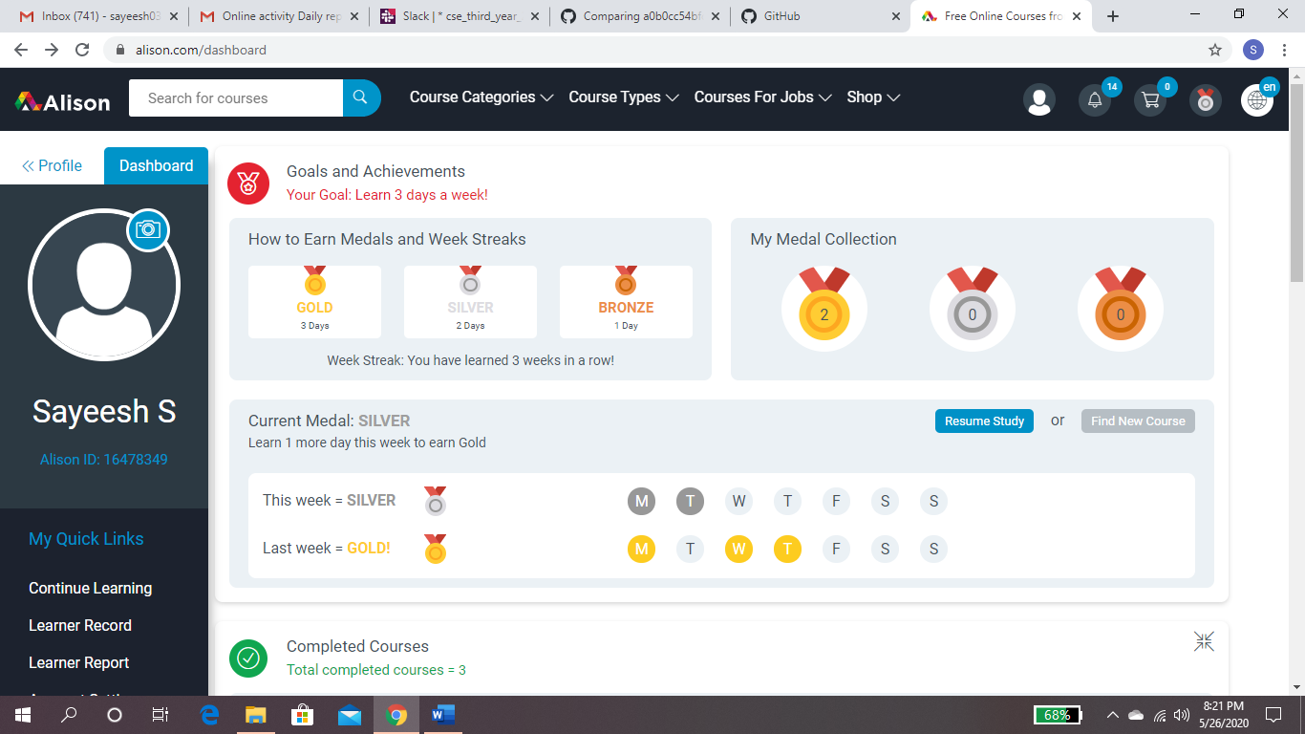

**Attended one week Faculty Development Program on “Artificial Intelligence"**

**(Evening 4.30 to 6)**

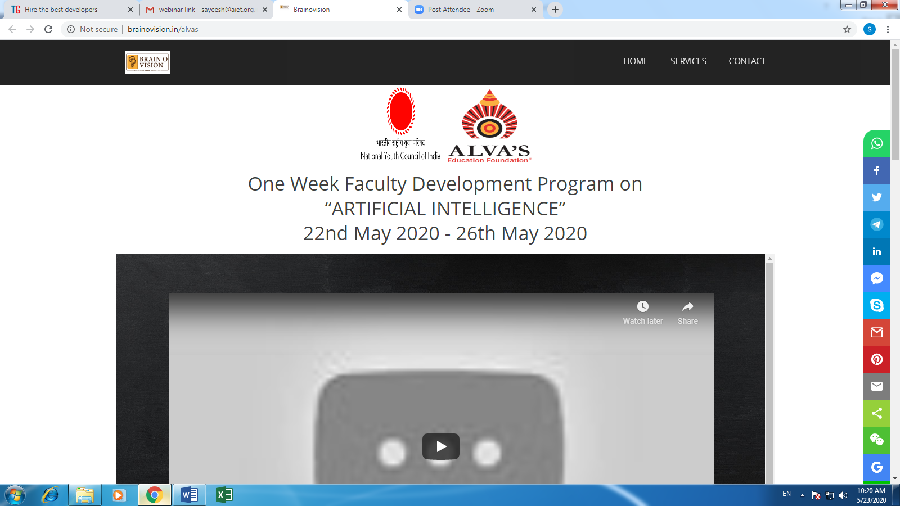

**CGV Test**

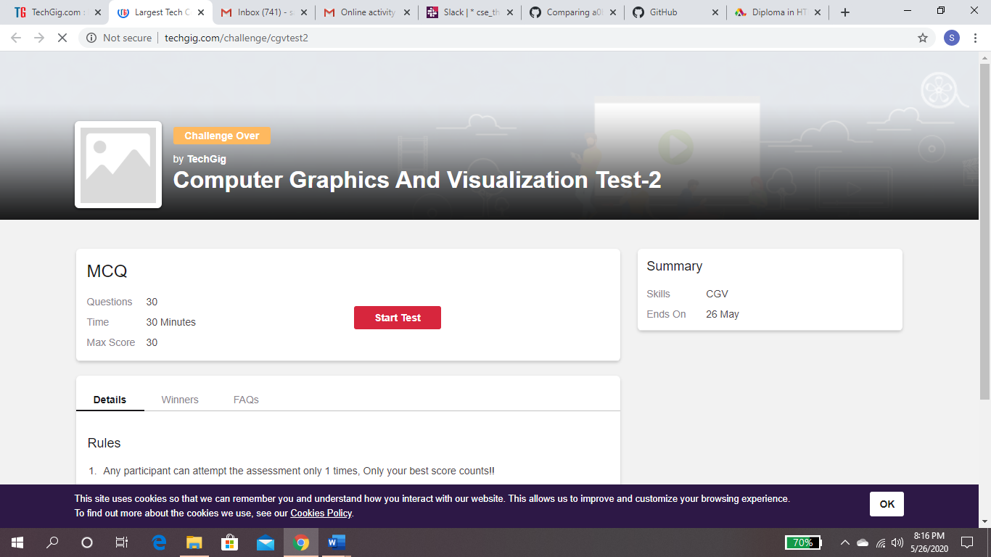

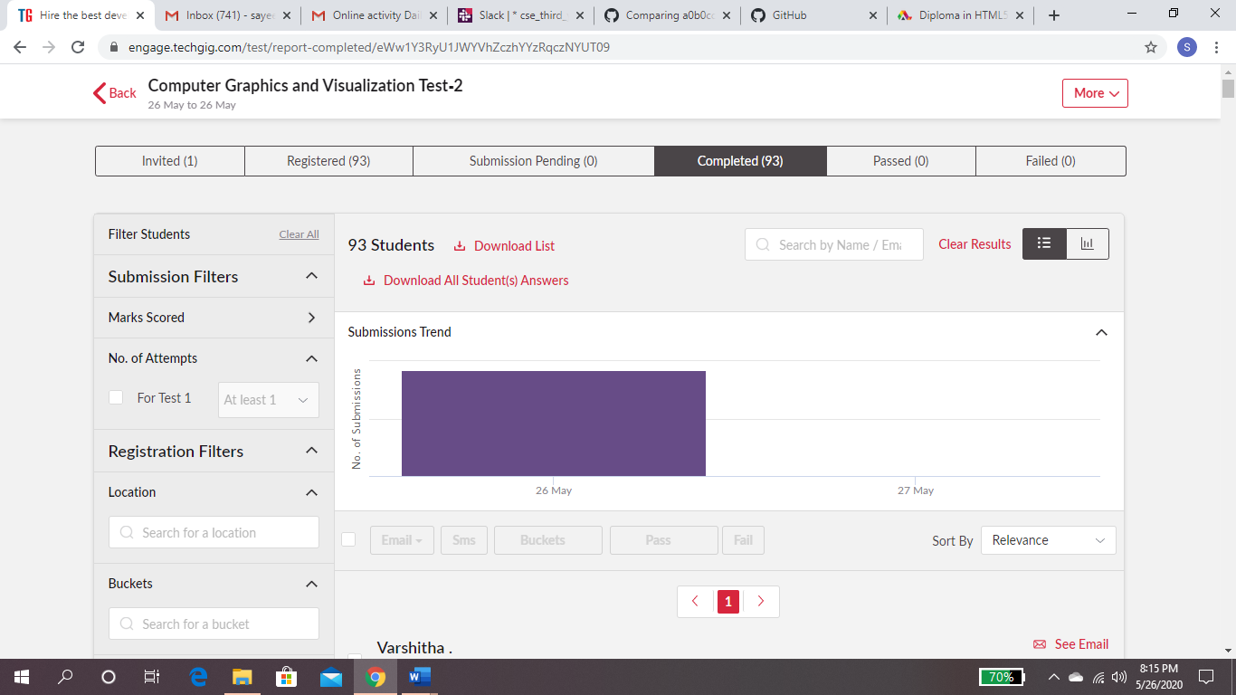

**Students Report:**

